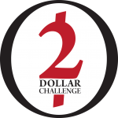

Bartering Challenge - Checklist

1. Make Double-sided copies of the Bartering Challenge Rules

2. Assign someone to lead Bartering Challenge

3. Send Bartering Challenge Email

4. Gather participants in one location

5. Review the Rules with all Participants

6. Organize them into teams

7. Have each team member sign waiver

8. Remind participants to re-gather at this location in 2 hours to count totals

9. Announce Winning Team

